# Case Study Assignment: Blog API - Spring Boot Project with Amazon RDS (MySQL)

Step 1: create project name as blog and it should have all crud operations.

Step 2: Login in to your AWS account with right credentials .

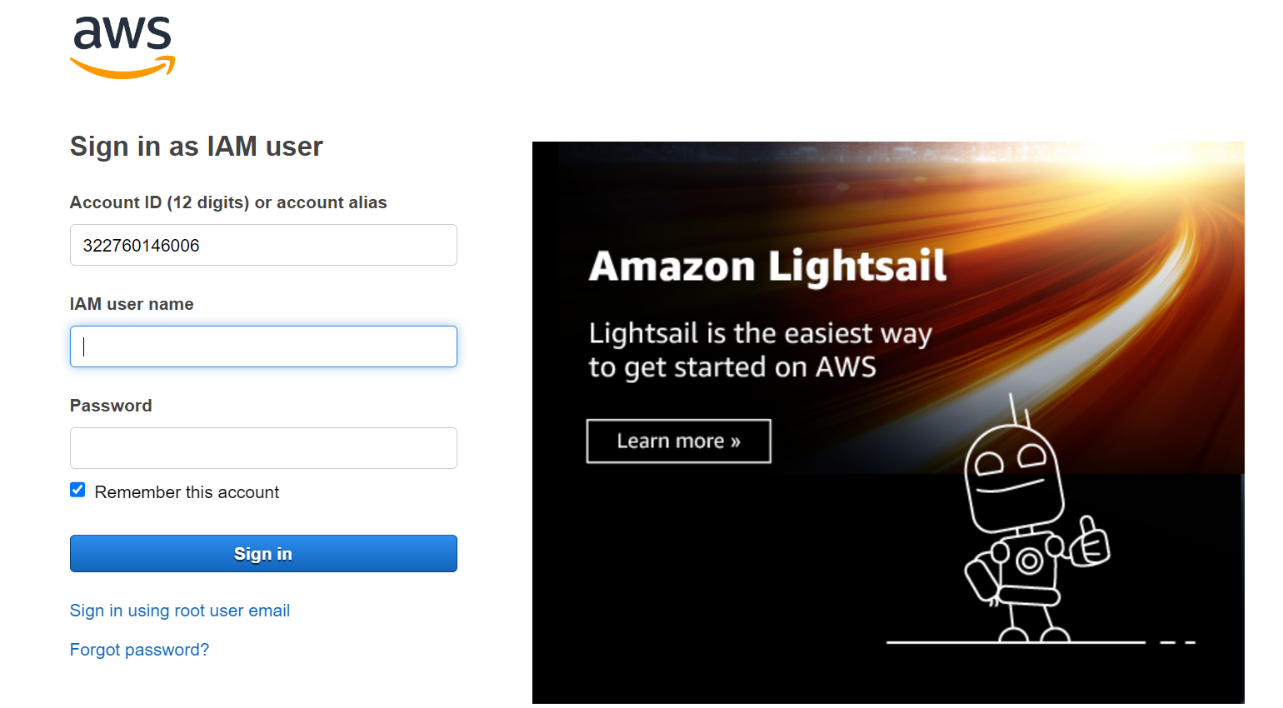

Step:3 you will see home page as below

Step4:type EC2 in search bar . you can see as below image .

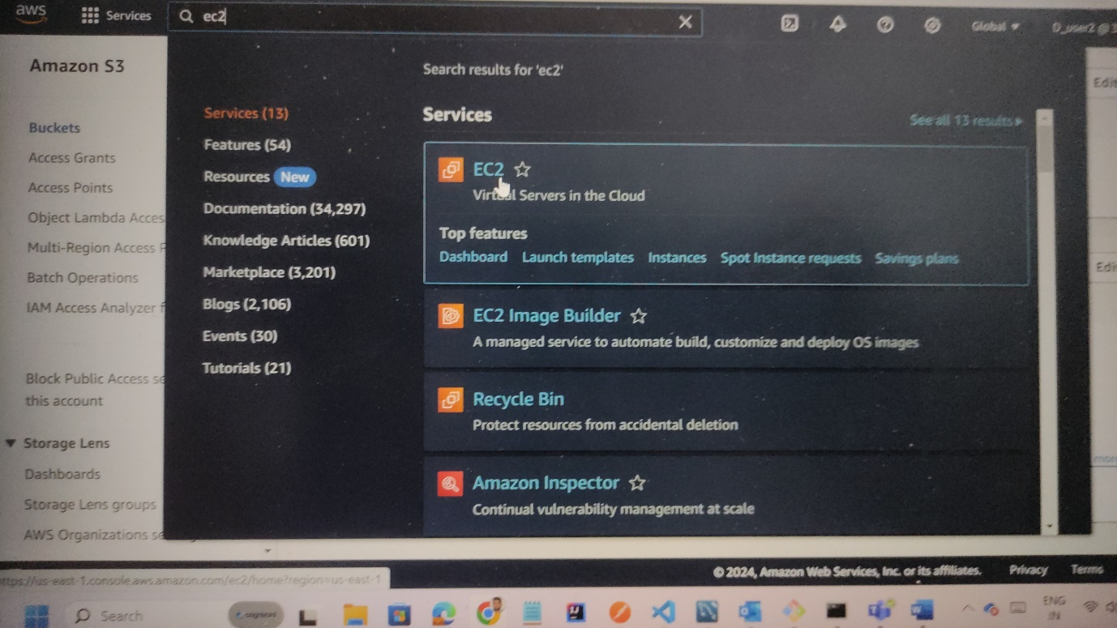  
step5:click on security groups in left pane as shown in below image.

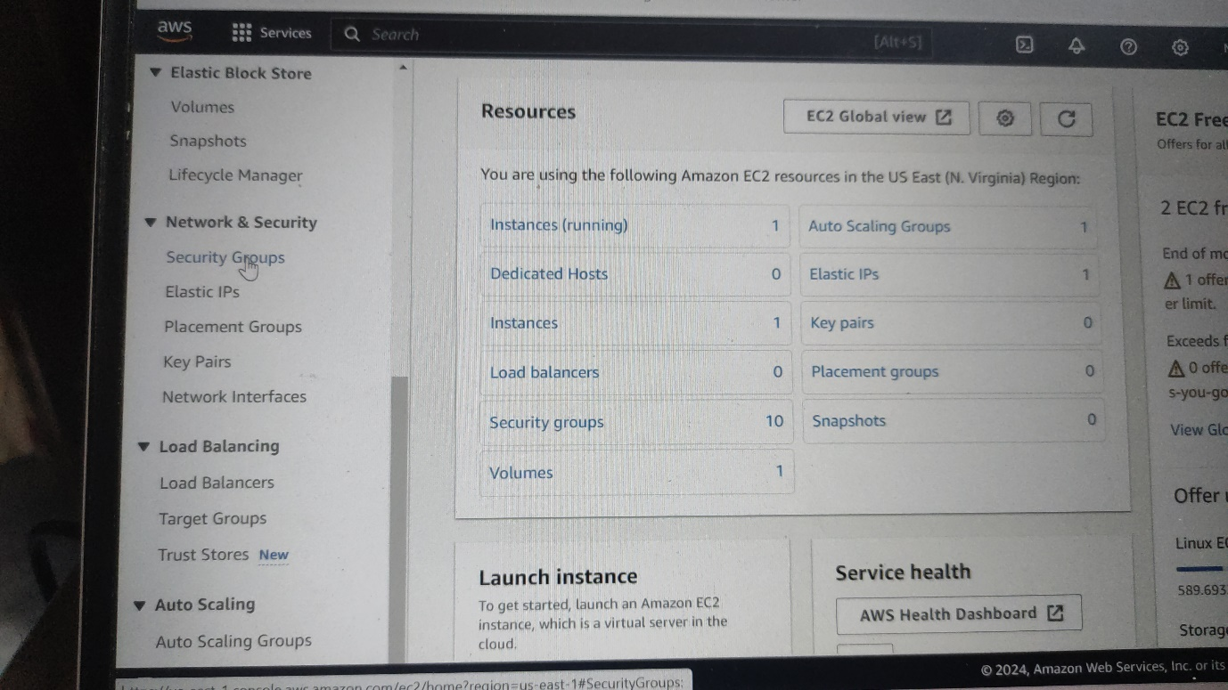

Step7: click on create security group as shown below image

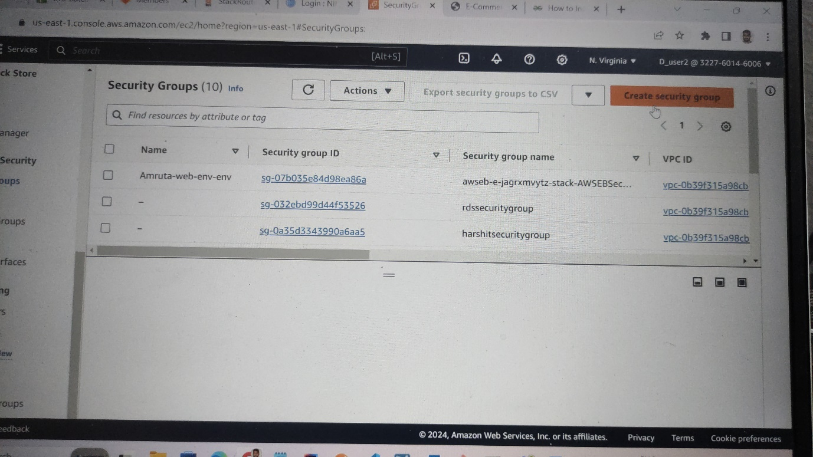

Step8: write security group name and also description I given fields as shown below image

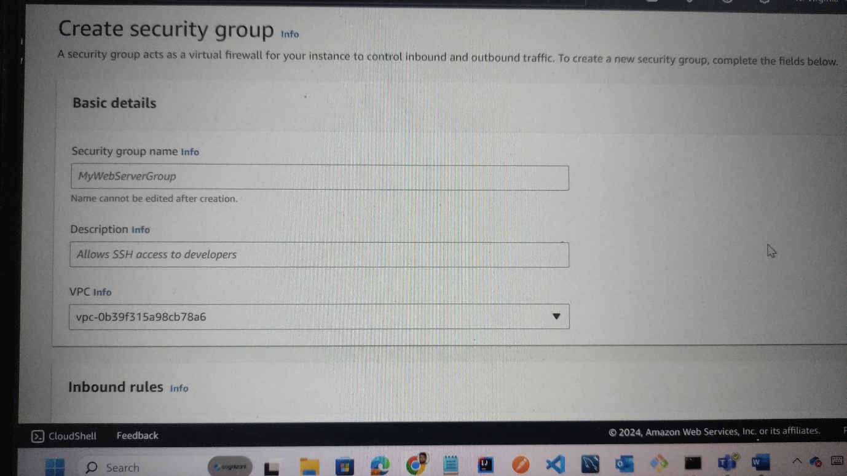

Step9:change the inbound and outbound rules . as “all traffic” and select “anyhwere IPV4” for both inbound and outbound rules as shown below image.

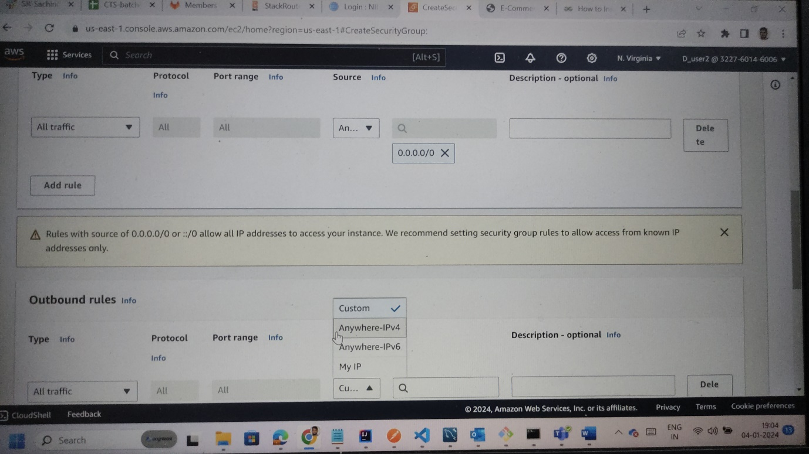

Step10: click on create security group and security group will be created.

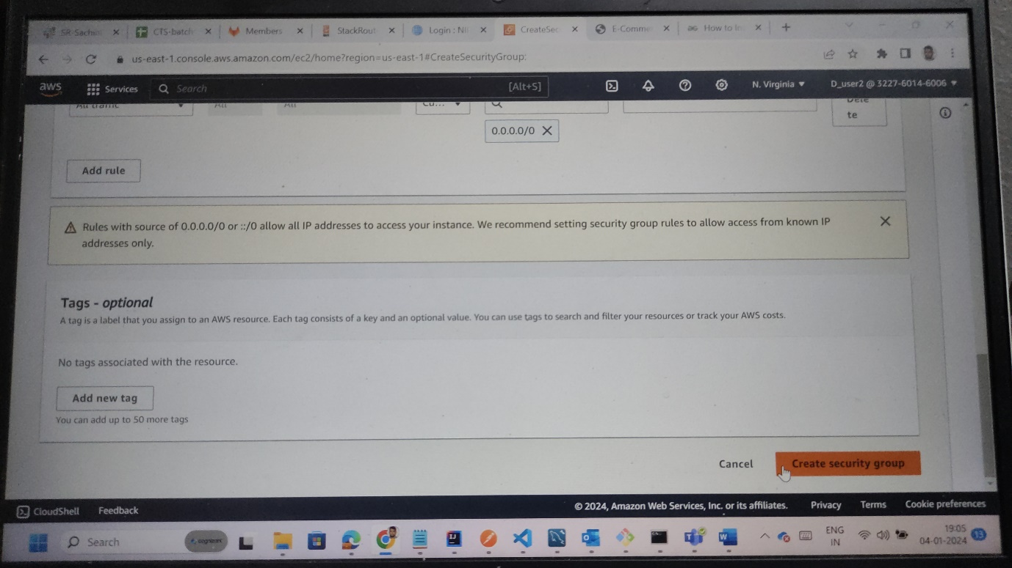

Step11: in search bar write as RDS we get ass RDS on image below.

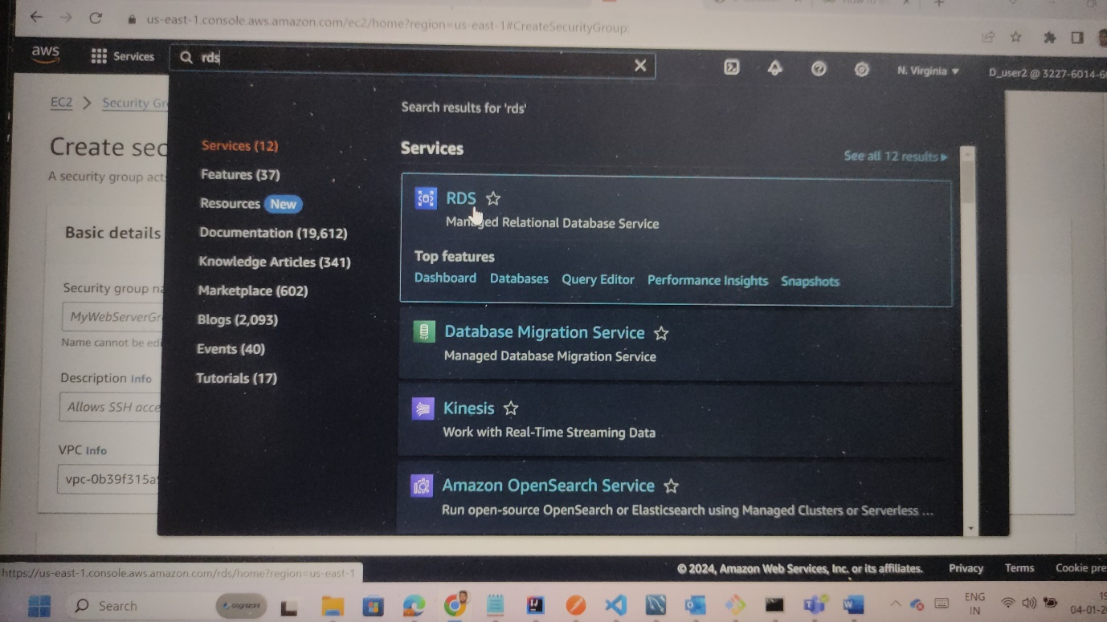

Step12: ypu will find ass dbinstances in RDS as shown below . click on that.

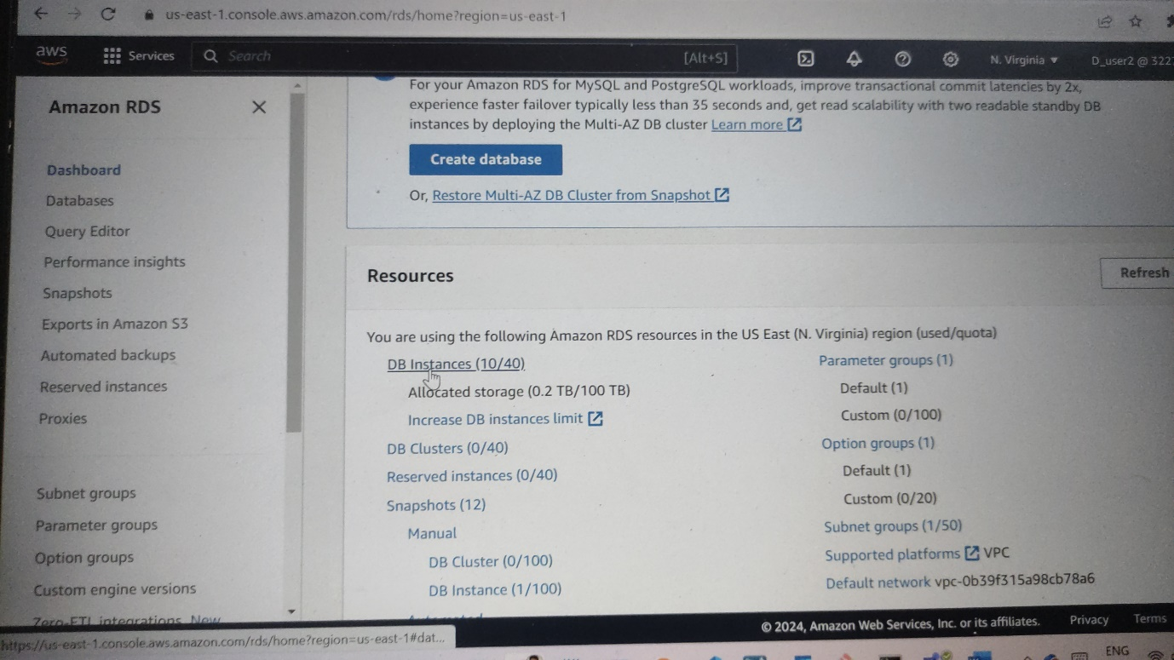

Step13:here we can find create database option click on it .

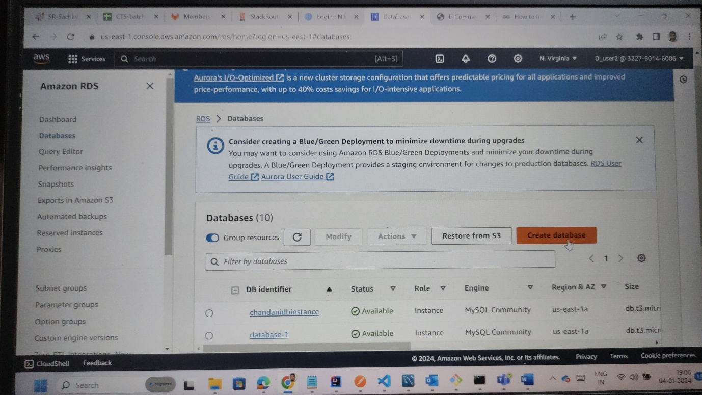

Step14:select as standard create and we can choose very different db;s provided by AWS in our case we are going to use MYSQL as shown below

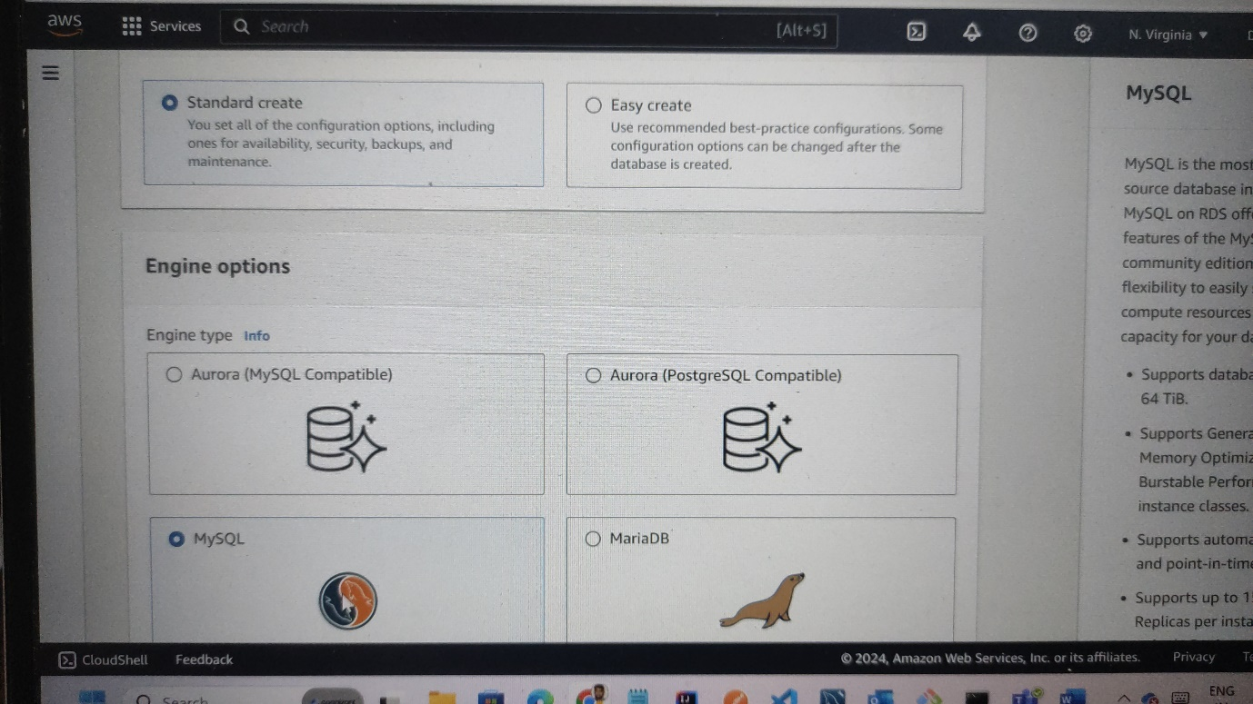

Step15:select the free tier option as for learning part . infuture if necessary we can se other services.

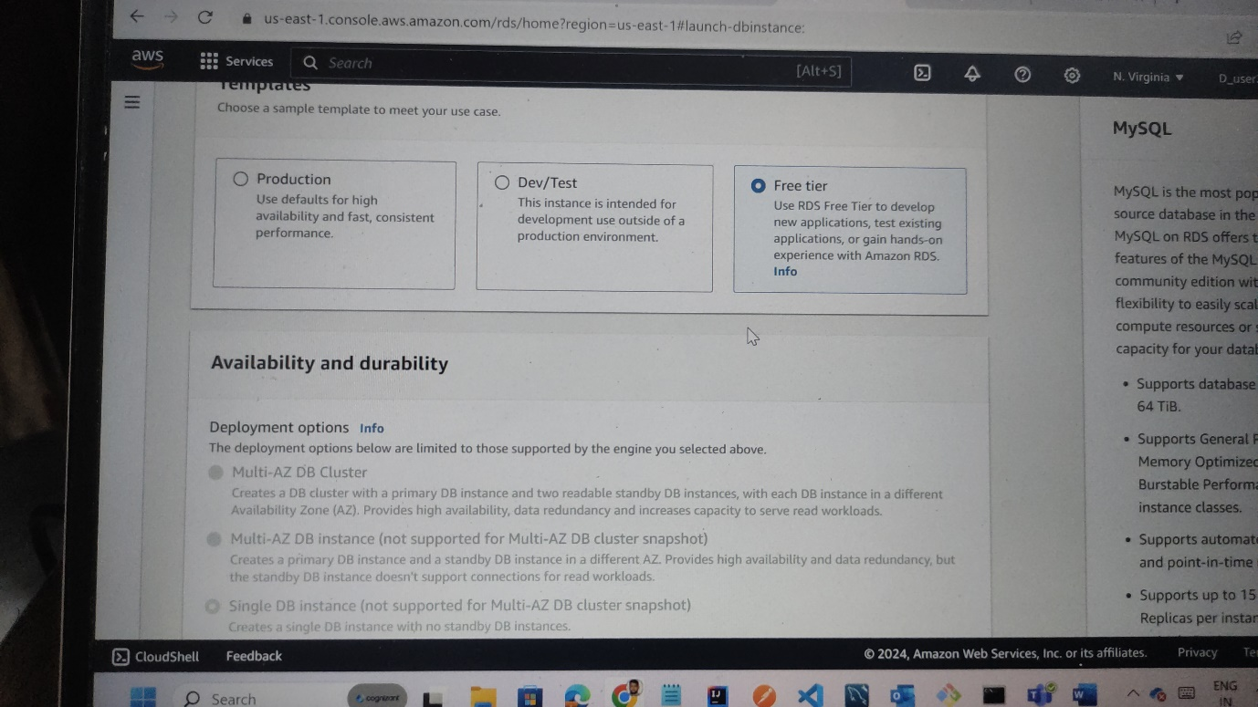

Step:16:provide the credentials like master password and confrm it as shown below image.

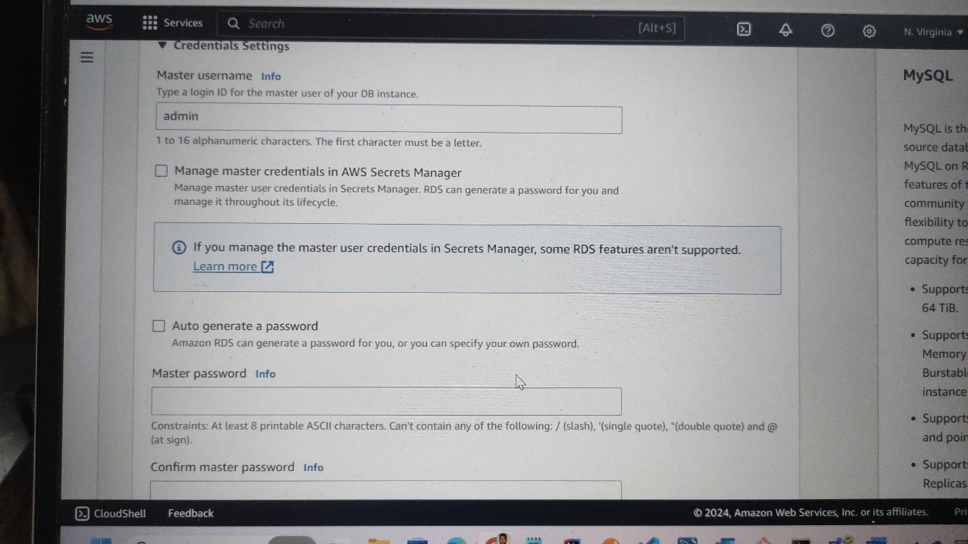

Step17:select public access for now . so it could be visible to all.

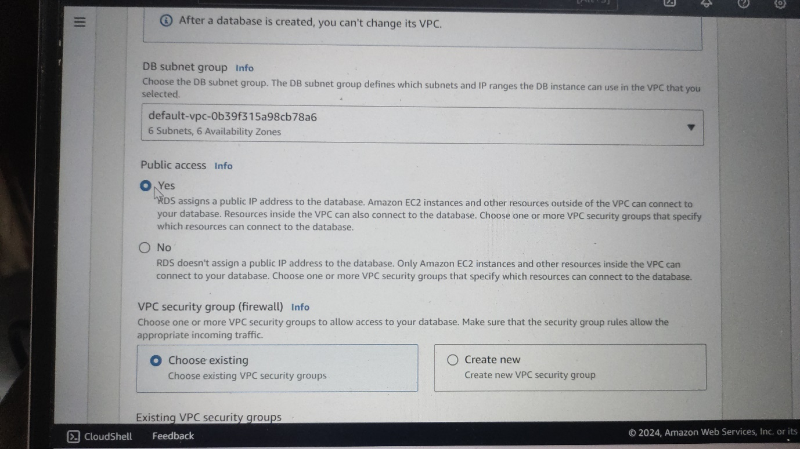

Step18:select the secuirty group that we have created in EC2 and use that here.

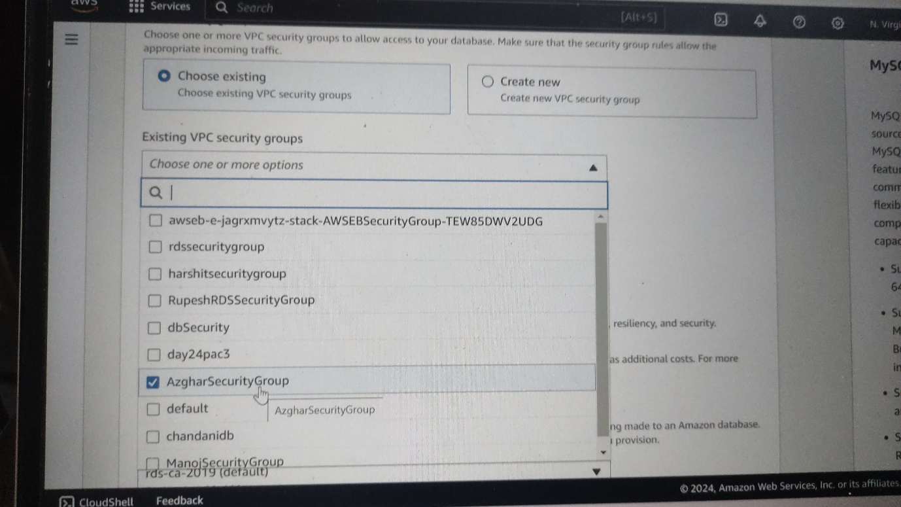

Step19: click on cerate database .

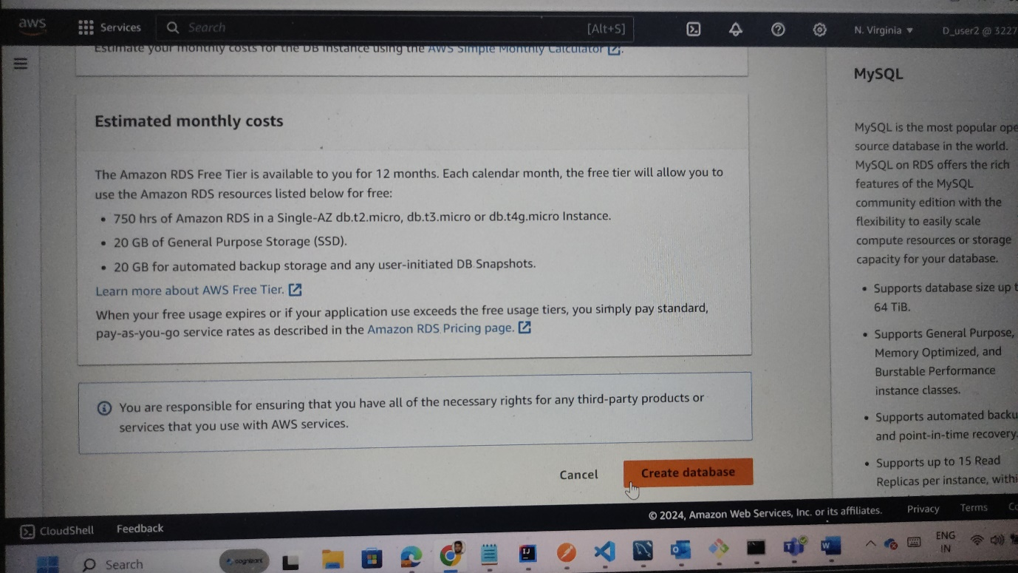

Step20: after creating database we can find our database in here as shown below.

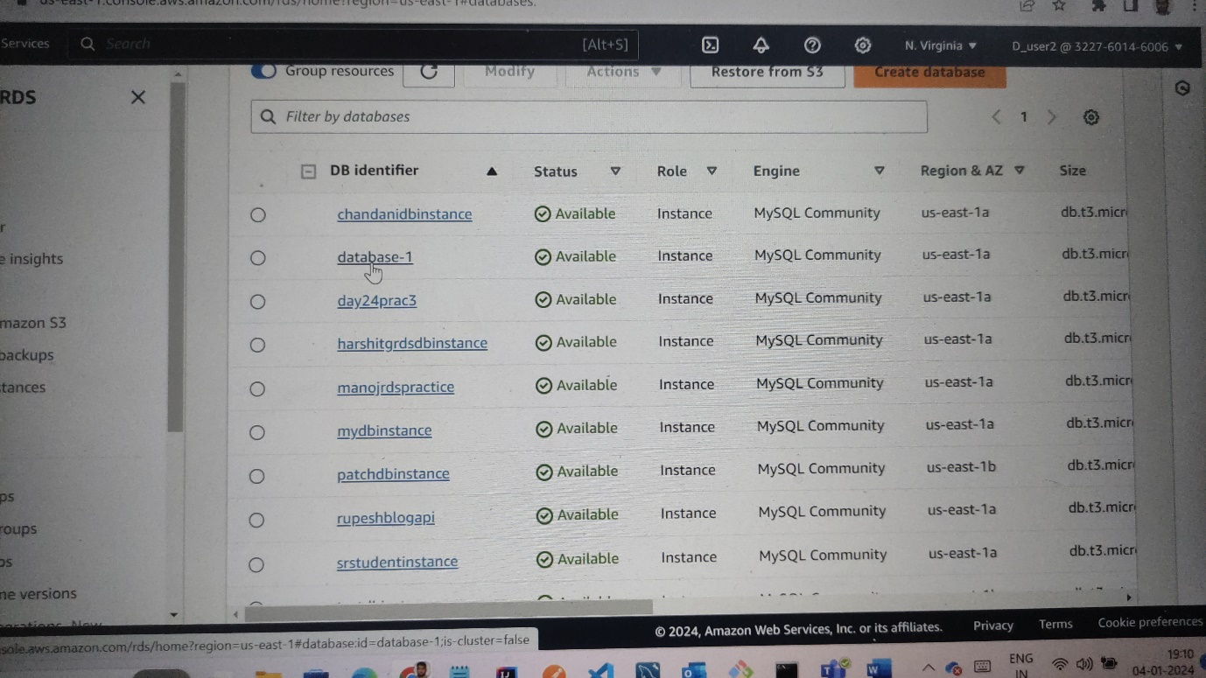

Step21:click on your newly created database you can d=fin gurl as shown below . copy the url as shown in below image

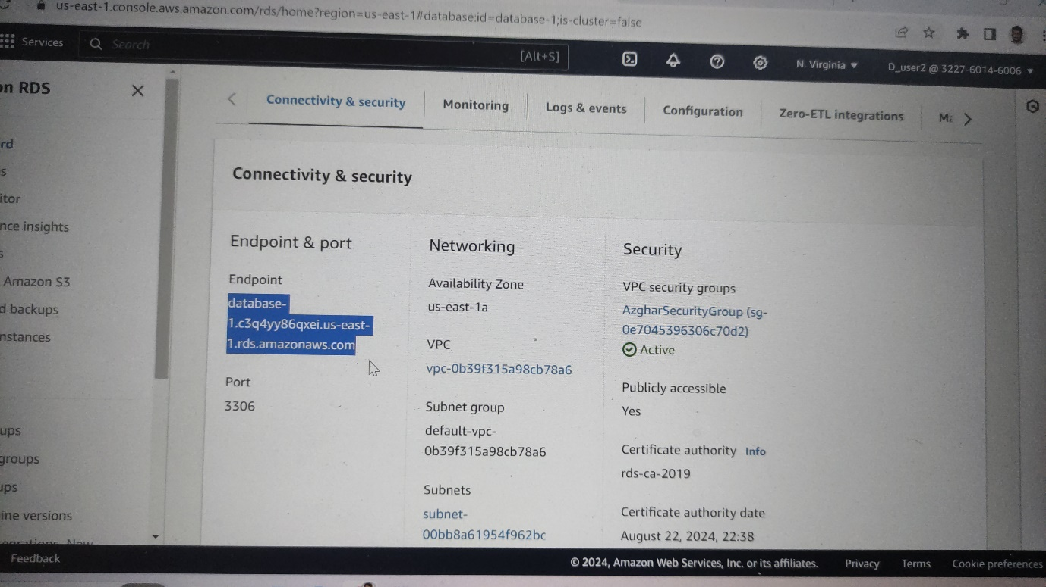

Step22: open your local workbench . click on “+” to create a new connection . giver username anything and username as “admin” and password should be what you provided when creating the database .click on test connection . you will be msg as connection established as shown below.

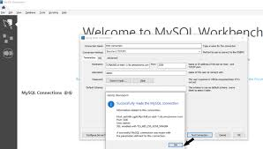

Step23:after connection is established in your project that is Blog project . application properties should be modified by giving RDS url as shown below and run the program

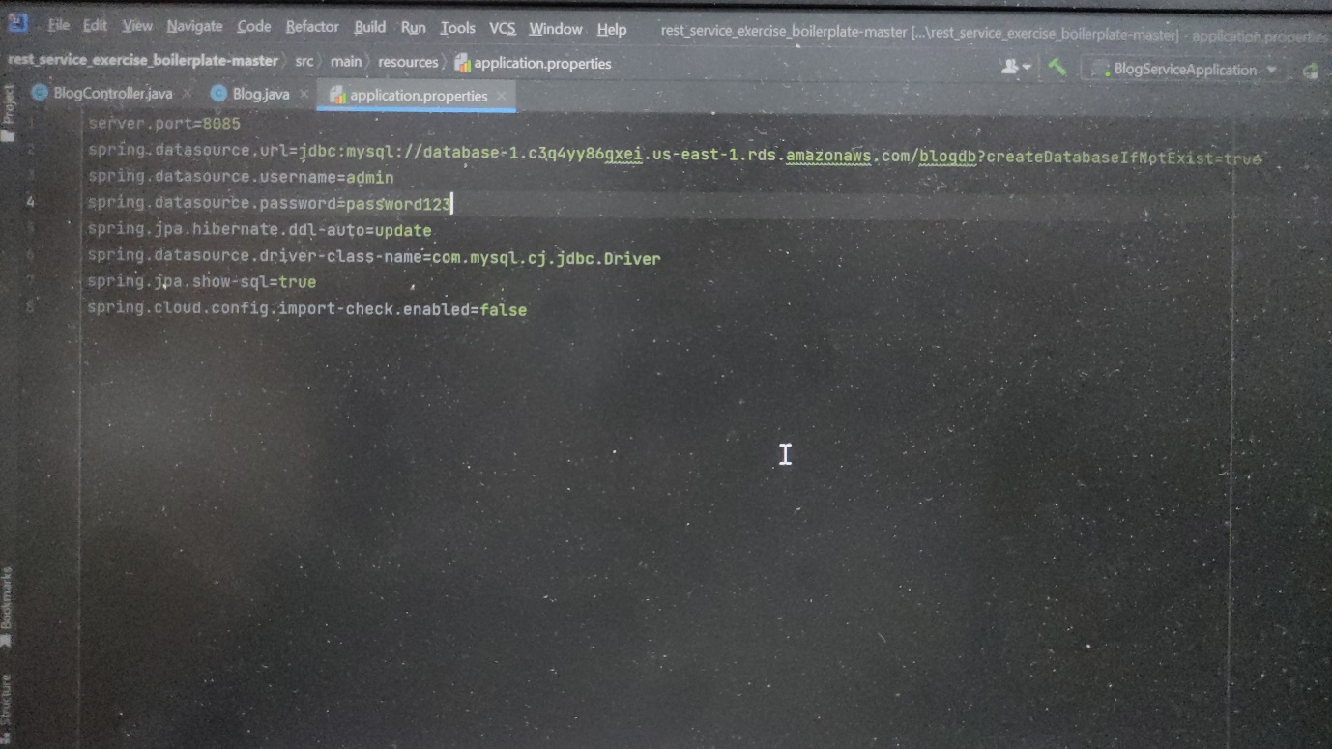

Step24: after program is runned successfully. Open postman and hit the url from our project and provide necessary data in body and hit the link. If data is posted or get or delete . the we sucessfully made connection with RDS.

